Why the SaniBook:



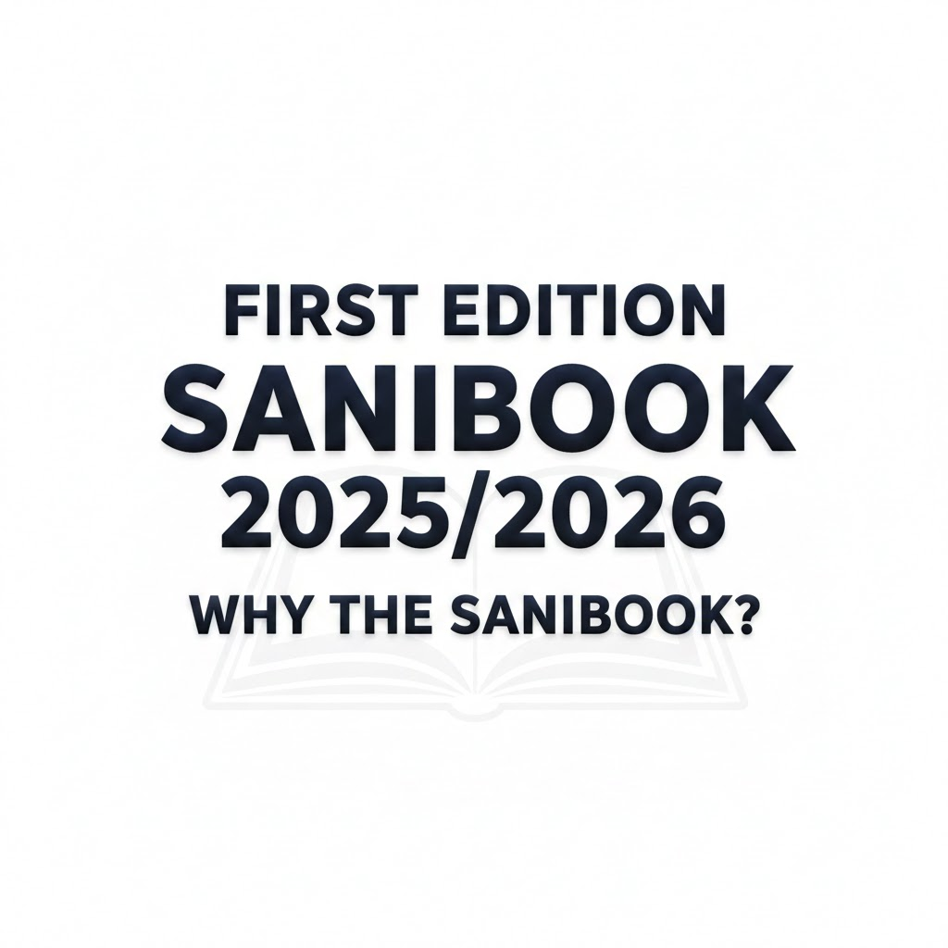



**

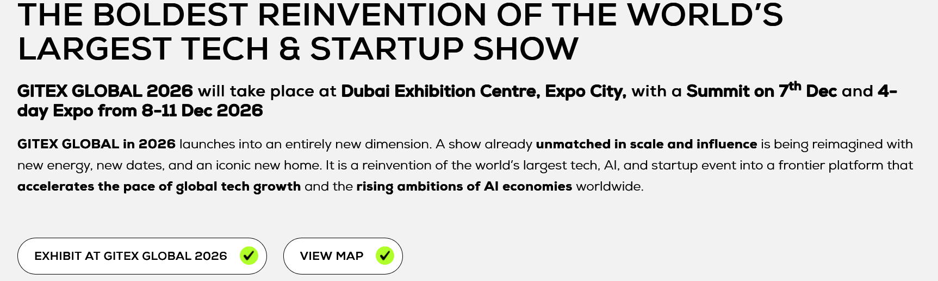

*Sanibook: Revolutionize sanitation information: Turning every intervention into a documented success story for a healthier, cleaner Kenya.*

***Kenya's sanitation solutions are working, but they're invisible.*** *Despite countless successful interventions, fragmented data and poor documentation prevent learning and coordination.* ***Sanibook changes this*** *by unifying these efforts to amplify success and drive collective progress.*

Synopsis

Support SaniBook

**Support the sanibook**

**Sponsor SaniBook: Investing in Global Health and Sustainable Impact**

**Invest in Health, Impact the Future: Sponsor SaniBook**

**The Critical Need: Why SaniBook is Essential**

Sanitation and hygiene are the foundation of public health and economic prosperity. Yet, a significant portion of the population lacks access to consistent, reliable, and culturally appropriate hygiene education.

The **SaniBook** is a vital, accessible resource designed to bridge this gap. It provides:

* **Information Sharing Platform**: It centralizes scattered sanitation data, acting as a single source of truth to eliminate duplicated efforts and dilute accountability.
* **Shared National Work-plan**: The inaugural edition focuses on identifying and converting seven key sanitation bottlenecks into a unified national action plan.
* **Delivering Maximum Impact**: It provides a common reference point, built on the principle that collective action is the most significant multiplier for success in the sector.

SaniBook is not just a book—it is a sustainable, scalable solution to public health challenges.

**The Partnership Advantage: How Your Organization Will Benefit**

By partnering with us to support the distribution and development of SaniBook, your organization will achieve significant and tangible benefits:

| Sponsor Benefit | Description of Impact |
| --- | --- |
| **Enhanced Corporate Social Responsibility (CSR)** | Your brand will be recognized as a **champion of public health and sustainable development**, directly aligning your values with global well-being goals. |
| **Extensive Brand Visibility & Reach** | Your organization's logo and acknowledgement will be prominently featured in all sponsored copies of SaniBook, reaching thousands of families, schools, and local leaders in key demographics. |
| **Demonstrable Social Impact** | We provide **detailed impact reports**, allowing you to quantify your contribution to disease reduction, improved school retention, and community productivity. |
| **Positive Stakeholder Perception** | Strengthen your relationship with consumers, employees, and investors who increasingly prioritize businesses with a genuine commitment to social good. |
| **Thought Leadership in Health** | Position your organization as an innovator and leader dedicated to evidence-based solutions in the critical sectors of health and hygiene. |

**Synopsis**

**SaniBook 2025: Breaking the Chain and Unlocking Kenya's Sanitation Future!**

**SaniBook: The Definitive Nexus for Kenya's Sanitation Future** is launching its inaugural 2025 edition, ***Breaking the Chain: Unpacking Kenya's Seven Critical Sanitation Bottlenecks***. Developed as the strategic compass from the **Second Sanitation Accountability Symposium (SanAccs II)**, SaniBook is poised to be the **definitive, one-stop resource** for mapping Kenya Sanitation Interventions

**Synergizing for Maximum Impact**

SaniBook is a crucial **game-changer** designed to **synergize all stakeholders**—government, NGOs, private sector, and academia—to finally break down paralyzing silos. Its primary mission is to create **unprecedented coordination**, streamline efforts, and drive maximum impact toward achieving **sustainable and safely managed sanitation for all Kenyans**.

**Unpacking the Seven Critical Bottlenecks**

The core of this inaugural edition is its **evidence-based analysis** of the **Seven Critical Sanitation Bottlenecks** that continuously undermine national progress. These failures span the entire service chain, including:

* Low access to sanitation and Inadequate Capacity
* Institutional Fragmentation.
* Poor technology and innovation adoption
* Chronic Underinvestment
* Significant Policy and Regulatory Gaps in non-sewered sanitation.
* Persistent Behavioral Barriers.

By clearly articulating these seven key points of failure, SaniBook provides a **shared, quantified understanding** of the challenges, moving the sector from generalized awareness to **targeted, actionable intervention planning** that maximizes economic returns and public health outcomes.

**The National Sanitation Directory (NSD): Your Role in the Ecosystem**

To transform this knowledge into collective action, the SaniBook integrates the **National Sanitation Directory (NSD)**. This directory is the **vital mechanism** for providing the foundational intelligence necessary for systemic sector expansion and attracting investment. The NSD aims to:

* **Eliminate Resource Duplication**.
* **Benchmark Professional Standards**.
* Clearly identify organizations with the necessary **supplies, technical skills, and capacity** in specific geographic areas.

By aggregating data on service provision, we are transforming a fragmented industry into a **transparent, quantifiable ecosystem** ready to attract and absorb large-scale, sustainable impact investment.

**Data-Sharing for Universal Sanitation**

Kenya's 2030 sanitation goal is stalled by a **fragmented sector** where vital work happens in **isolated silos**. This absence of shared intelligence prevents us from accurately mapping national coverage, leading to **duplicated resources** in some areas and the neglect of true **"sanitation deserts."** To fix this, we must pivot from individual projects to **collective action**.

SaniBook is the mechanism for this transformation. Sharing your intervention data (location, technology, challenges) is a **crucial strategic investment**. This shared intelligence allows us to **eliminate duplication**, redirecting resources to the neediest areas and **maximizing reach**. By making your "lessons learned" visible, the SaniBook also **accelerates innovation** and signals to investors that the Kenyan WASH sector is organized and efficient.

Your data is a **puzzle piece**; without it, the picture of Kenya’s sanitation status is incomplete. Listing your intervention provides **industry recognition**, positions your organization as an accountable contributor to national strategy, and establishes the mutual trust needed to unlock large-scale funding. **Submit your data today** to build a truly coordinated, effective, and sustainable sanitation future for Kenya

**Call to Action: Secure Your Place!**

We are formally requesting **all organizations**—from small-scale service providers and technology innovators to large international NGOs and development partners—to **secure their place** in this critical framework.

**We ask that you:**

1. Share your organization’s **operational details**.
2. Articulate how your current interventions and programs are specifically designed to tackle **one or more of the Seven Critical Bottlenecks**.

Ultimately, the SaniBook transforms a historically opaque, high-risk sector into a transparent, quantifiable ecosystem primed for sustainable, large-scale impact investment. The aggregated, mapped data from the NSD serves as the ultimate roadmap, enabling investors to identify lucrative, untapped market white spaces and strategic expansion opportunities with reduced risk. By providing clarity on regional needs, organizational capacity, and validated impact, the SaniBook unlocks critical capital, fuels sustainable sector growth, and provides the essential scaffolding for a stronger, more coordinated sanitation future that is scalable and economically viable.

*Submit your data today and become a vital part of the solution.*



***WHY VISIONARY PARTNERS IN SANITATION SHOULD PARTICIPATE***

1. You'll gain a true competitive edge: Knowledge is power, and SaniBook is the undisputed, one-stop source for cutting-edge data, best practices, and regulatory shifts.

**

1. You'll expand your network exponentially: We're talking about a game-changing opportunity to connect with every influential stakeholder, policymaker, and potential partner under one roof. It's where deals are made and collaborations are born.



1. You'll cement your industry leadership: By contributing your expertise, you're not just participating—you're writing the playbook for the future of global sanitation. Be the benchmark, not the follower.



**Don't miss the bus!** Join SaniBook and ensure your organization's voice is not only heard, but **amplified** across the entire ecosystem.

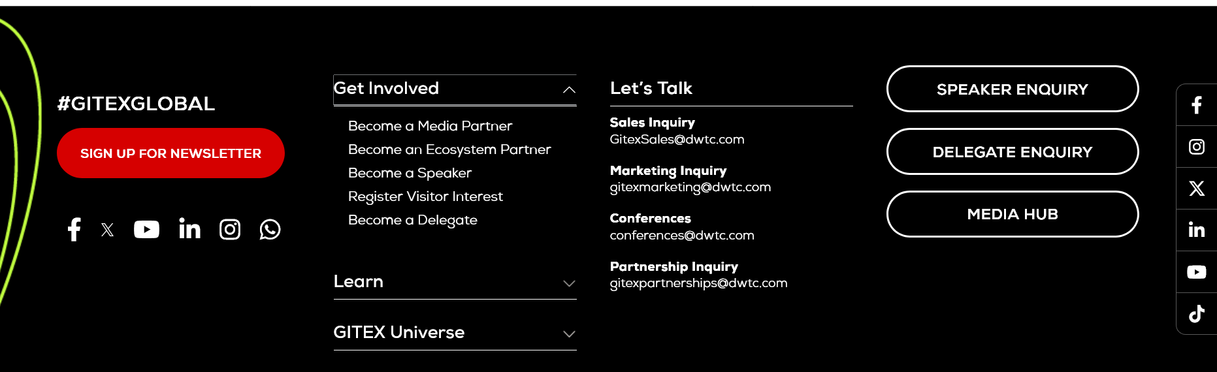

**Lets talk**

**info@washvoiceafrica.org**

**Sales Inquiry**

**Marketing Inquiry**

**Add your Voice**

***SaniBook***

**Get Involved**

**Tell Your Story**

**Invest in the SaniBook**

**Explore the SaniBook**

**Become a media Partner**

**Learn,**

**Your Sanitation information Kiosk**

***See Regular updates***

***Media Hub***